Project 1

MTH 3210-001 Probability and Statistics

Manoj Vasa

11/17/2016

Introduction:

The data in this study is gathered from restaurants serving pho in Denver, Colorado and New York, New York. All restaurants were strictly within these two cities. The item that I analyzed the prices for was a large bowl of pho served with beef. The following table lists the 30 prices of the item found in the restaurants of each city respectively.

|  |  |
| --- | --- |
| New York, NY | Denver, CO |
| 7.25  6.75  6.00  9  10  10  12.5  10  9  7.50  10.50  10  8.25  11  15  15  14  7.50  14  9.25  10  9  12  14  9  10.50  14  8.50  10  10 | 8.95  10  8.75  8.75  7.95  8.95  10.00  11.50  9.50  5.95  6.95  7.95  8.95  7.25  9.00  10  8.25  9.95  9.50  8.75  6.75  9.45  9.50  8.50  8.95  8.95  7.75  9.25  9.95  10 |

New York, NY

**Mean**: 10.317

**Standard** **deviation**: 2.486

Denver, CO

**Mean**: 8.863

**Standard** **deviation**: 1.158

Five number Summary:

New York

(6,9,10,12,15)

Denver

(5.95,8.25,8.95,9.50,11.50)

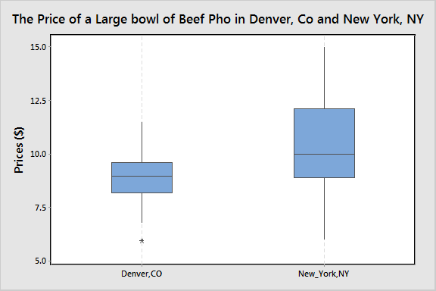

Confidence Interval at confidence Level 95%

New York, NY

α = .05

1 – (α/2) = .975

t.975,29 = 2.045

mean = 10.317

s = 2.486

10.317 - 2.045 * ($\frac{2.486}{\sqrt{30}}$) = 10.317 – 2.045*(.453879) = 10.317 - .928183 = 9.389

10.317 + 2.045 * ($\frac{2.486}{\sqrt{30}}$) = 10.317 + 2.045*(.453879) = 10.317 + .928183 = 11.245

Confidence interval: (9.389, 11.245)

With a 95% confidence level I can say that the true mean average of the data from New York, NY lies in the interval (9.389, 11.245).

Denver, Co

α = .05

1 – (α/2) = .975

t.975,29 = 2.045

mean = 8.863

s = 1.158

8.863 - 2.045 * ($\frac{1.158}{\sqrt{30}}$) = 8.863 – 2.045 *(.211421) = 8.863 – (.432356) = 8.431

8.863 + 2.045 * ($\frac{1.158}{\sqrt{30}}$) = 8.863 + 2.045 *(.211421) = 8.863 + (.432356) = 9.295

With a 95% confidence level I can say that the true mean average of the data from Denver, CO lies in the interval (8.431, 9.295).

Hypothesis test (calculations are on the last page)

Ho: µ0 - µ1 = 0

Ho: µ0 - µ1 ≠ 0

t = 2.904

invT(.975, 42) = 2.018

2.018

-2.018

0

The test statistic falls within the rejection region. So, we reject the null hypothesis.

Reject Ho

P-Value Test

2(tcdf(2.018, 100, 42)) = 2(.025) = .05

P-Value = .05

α = .05

P-Value = α

Reject Ho

Final Conclusions:

As we can see through the Confidence intervals and both of the hypotheses tests, the prices of the food item is different depending on which city they are purchased at. With a confidence interval of (9.389, 11.245) with a confidence level of 95% we can see that the true mean average of the prices of the item in New York would yield a higher value than that of Denver, CO. The confidence interval of the prices of the item in Denver, CO was (8.431, 9.295). The true mean average as we can see here lies in an interval with a lower upper bound and lower bound than the New York confidence interval. This concludes that the prices of this food item in New York would be typically higher than those in Denver, CO.

Through the rejection region hypothesis test we conclude that we can reject the null Hypothesis due to the test statistic landing in the rejection region. This provides the conclusion that the two means of the sample differ significantly. The calculated P-value of the data was .05. This is exactly equal to α. This also means that the Ho is rejected. The lower P-value indicates the statistical significance of the sample data I’ve collected. Thus, it indicates a true difference between the prices of the large bowl of pho in Denver, CO compared to the prices in New York, NY.